**List**

**What is list ?**

List is used to store the sequence of various of data .python list are **mutable type** .It means we can modify its element after it created

A list can be defined as collection of value or different types

Items separated by enclose with []

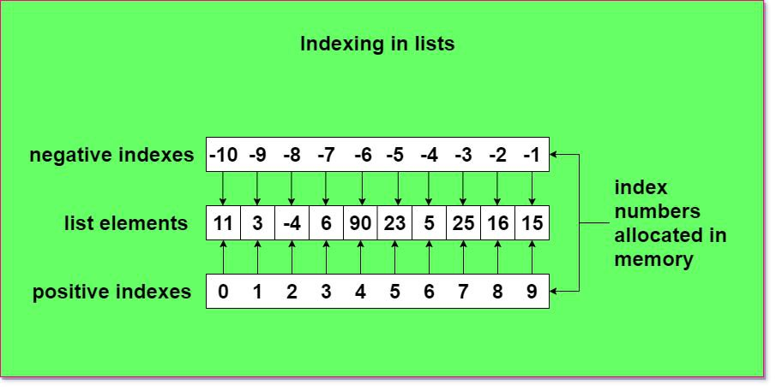

**Slicing in list**

Slicing is the extraction of a part of a string .list or tuple it enables users to access the specific range of element by mentioning their index.

Syntax: object [start : stop : skip ]

**List methods**

1. Append ( )
2. Copy ( )
3. Clear ( )
4. Count ( )
5. Extend ( )
6. Index ( )
7. Insert ( )
8. Pop ( )
9. Remove ( )
10. Reverse ( )
11. Sort ( )

1)append

append

uma=[1,2,3,4,5,6,7,8,9]

uma.append(123)

print(uma)

2) extend

uma=[1,2,3,4,5,6,7,8,9]

uma.extend([123])

print(uma)

3) count

uma=[1,2,3,4,5,5,5,6,7,8,9]

print(uma.count(5))

4) index

uma=[1,2,3,4,5,6,7,8,9]

print(uma.index(3))

5 ) clear

uma=[1,2,3,4,5,6,7,8,9]

uma.clear()

print(uma)

6) copy

uma=[1,2,3,4,5,6,7,8,9]

b=uma.copy( )

print (b)

7) insert

uma=[1,2,3,4,5,6,7,8,9]

uma.insert(2,"devi")

print(uma)

8) pop

uma=[1,2,3,4,5,6,7,8,9]

uma.pop(4)

print(uma)

9 ) remove

uma=[1,2,3,4,5,6,7,8,9]

uma.remove(5)

print(uma)

10) clear

uma=[1,2,3,4,5,6,7,8,9]

uma.clear()

print(uma)

11) reverse

uma=[1,2,3,4,5,6,7,8,9]

uma.reverse()

print(uma)

**Sort**

Sort is two types ascending order and descending order

sort ascending order

C=[1,2,3,4,5,6,7,8,9]

C.sort()

print(C)

sort desending order

  C=[1,2,3,4,5,6,7,8,9]

  C.sort(reverse=True)

**List comphersion**

[ Expression For Item In Iterable ]

 [x**2 for x in (1,2,3,4)]

print(list)

list /short hand if using and for loop

list = ["EVEN" if i % 2==0 else 'odd' for i in range(10)]

print(list)

fruits=["apple","banana","cherry","kiwi","mango"]

newlist=[x for x in fruits if "a" in x]

print(newlist)

index

s=[ 1,2,3,4,3,4]

for i in range(len(s)):

    if s[i]==3:

        print(i)

index/how many 6 are presented in string

str1=[1,6,6,6,6,2,4,5]

n=[]

for i in str1:

  if i==6:

 str1.remove(6)

    else:

    str1.remove(6)

else:

  n.append(i)

print(n)